Physics 2501: Coupled Oscillators
T. Moran, 1977, D. Hamilton, 1987, and Ed Eyler, 2005.

The harmonic oscillator approximation is perhaps the most frequently used model in all of physics. This model can be extended to multi-body systems, such as atoms in a crystal lattice, by allowing multiple oscillators to weakly perturb one another. In this lab we study the simplest such coupled system, a pair of simple harmonic oscillators weakly coupled by a spring.

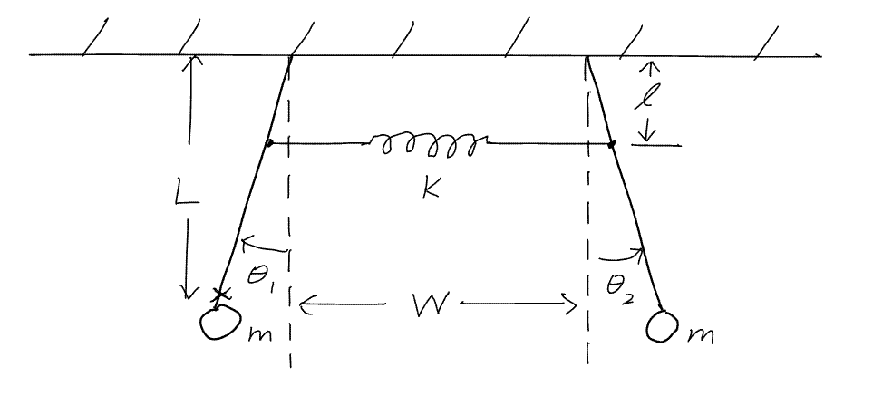
I. Equations of Motion
Figure 1. Coupled oscillators. L = vertical distance from support to center of mass (marked ‘X’), l = vertical distance from support to where coupling spring is attached.
Consider the two identical pendulum bobs displayed in Fig. 1. Without the coupling spring, the small-amplitude motion of either pendulum is described by
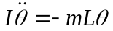
where I is the moment of inertia about the pivot point and L is the distance from the pivot to the center of mass. The resulting motion is simple harmonic,
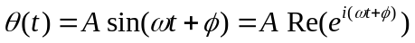,
where the angular frequency is
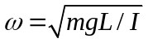.
Now consider a situation in which the two pendulums are coupled together by a spring whose spring constant is k and whose unstretched length is S₀. If l is the distance from the pivot to where the spring is attached and W is the distance between the two pivot points, then show that in the small-angle approximation the spring is stretched by a distance
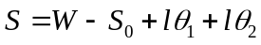.
The angular equations of motion, including the torque from the spring as measured at the pivot point, are
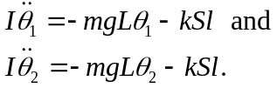
or, expanding out S using Eq. ,
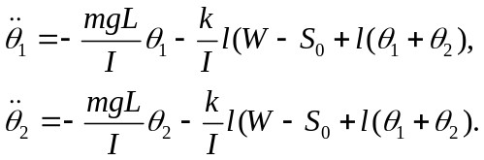
Finally, the equations can be arranged to explicitly reveal how each pendulum affects the other via the coupling k,
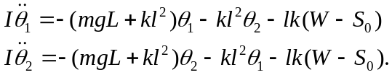
The equilibrium angles of the pendulums are no longer vertical due to the torques from the spring. Show that for either pendulum, the angular displacement θ ₀ of the new equilibrium position can be found by balancing the torques due to gravity and the spring to give, in the small-angle approximation,
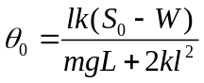.
Now we can define new angles that are measured from equilibrium,
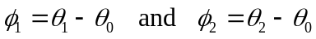.
Making this substitution in Eqs. above, we find
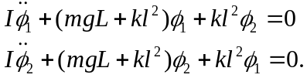
Assuming that φ1 and φ2 are sinusoidal oscillatory functions of time with amplitudes A and B, φ1 = Ae^{iωt} and φ1 = Be^{iωt}, (or the equivalent real notation using cosines), we can solve for the natural or normal frequencies of the system,
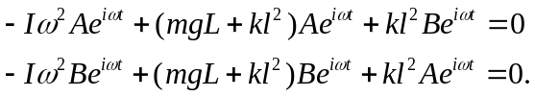
After collecting terms and canceling the common factor e^{iωt} we find that
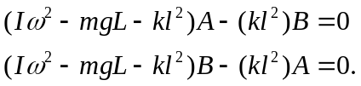
If a nontrivial solution exists for this pair of simultaneous equations, then the determinant of the coefficients of A and B must vanish,
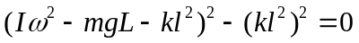.
Equation is quadratic in ω2, and thus there are two solutions,
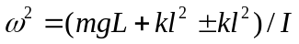,
or
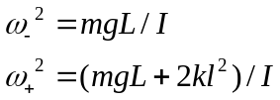,
One of the main points to be emphasized here is that each pendulum oscillates as a linear combination of only these two frequencies. Thus any motion whatsoever of each can be described as a sum of two harmonic functions, the normal mode frequencies. This is a general result for coupled oscillators. A set of N coupled oscillators can always be described as a sum of oscillations involving no more than N normal mode frequencies. In the present case one of the normal modes corresponds to the pendulums moving together “in phase,” and the other corresponds to oscillation “in opposition,” with a higher frequency because of the involvement of the coupling spring in this motion.
If the two normal mode frequencies are not too different, it is often easy to see the beat note between them if the system is excited in a superposition of the two modes. The strongest beats occur if both normal modes are excited with the same magnitude A₁. In this case we can rewrite the general solution for the motion of one of the pendulums in terms of sum and difference frequencies,
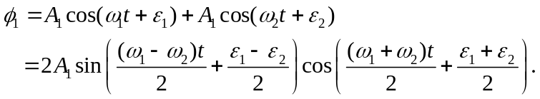
The slowly-modulated “envelope” at the frequency (ω₁ - ω₂)/2 goes through zero twice in each period, so the number of nodes per second in the beat note is equal to the difference of the two normal mode frequencies measured in Hz, 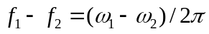.

II. Experimental Procedure
- Uncouple the two pendulums and measure their individual resonant frequencies for small amplitude oscillations. These two frequencies must be nearly equal for the analysis above to apply, otherwise you are will need to solve the problem for the more general case where the two uncoupled frequencies are different. Because the coupling has just a small effect on the frequencies, you need to make an accurate measurement here.
- Now couple the two pendulums together with the spring, choosing a convenient value of l. Measure the two normal mode frequencies which result from the coupling. Do this by first setting the pendulums in oscillation together, and then in opposition. Again, high accuracy is needed.
- Find the difference in the normal mode frequencies by the methods of beats. To do this it is necessary to start the pendulums oscillating in a mixed mode. You can get a nearly equal mixture of the two normal modes if you start the oscillations by holding one pendulum vertical, displacing the other one and then releasing both together. Compare your results to the difference between the two normal mode frequencies obtained above. Which method is more accurate, and why?
- Measure the force constant k of the coupling spring, using any reasonable method, and use this value to calculate the normal frequencies using the theoretical treatment in Section I. Be sure that the spring constant does not vary in the range of stretching that you used; if it does, use an average value. Compare your calculated normal mode frequencies with the measured ones. For the moment of inertia I, it is easiest to use an experimental value, which you can obtain from the analysis of part (1).
- Repeat steps 2, 3, and 4 for at least two different locations l of the coupling spring.
- If you start the coupled pendulums in an manner you wish, you will note that after some tens of minutes, the system will revert to oscillating in a nearly pure mode at the lower normal mode frequency, especially if the spring has losses (a rubber band works well for observing this effect). Explain why the higher-frequency mode damps out faster.
- In your writeup, be sure to address the two questions in Section I prefaced by “show that…”.

III. Resources
  - Principles of Mechanics, by Synge and Griffity, McGraw Hill, 1959, pp. 188 ff.
  - Mechanics, 3rd Edition, by K. R. Symon, Addison Wesley, 1971, pp. 195 ff., 469 ff.
  - Classical Mechanics, by H. Goldstein, Addison-Wesley, 1953.
  - For beats: almost any good introductory physics textbook.

